***For Windows Operating System Users:***

***Step1: Download Node.js (***[***https://nodejs.org/en/***](https://nodejs.org/en/)***).***

What is Node.JS?

Node.js is an open-source, cross-platform, JavaScript run-time environment that executes JavaScript code outside of a browser.

1.1) Click on <https://nodejs.org/en/>.

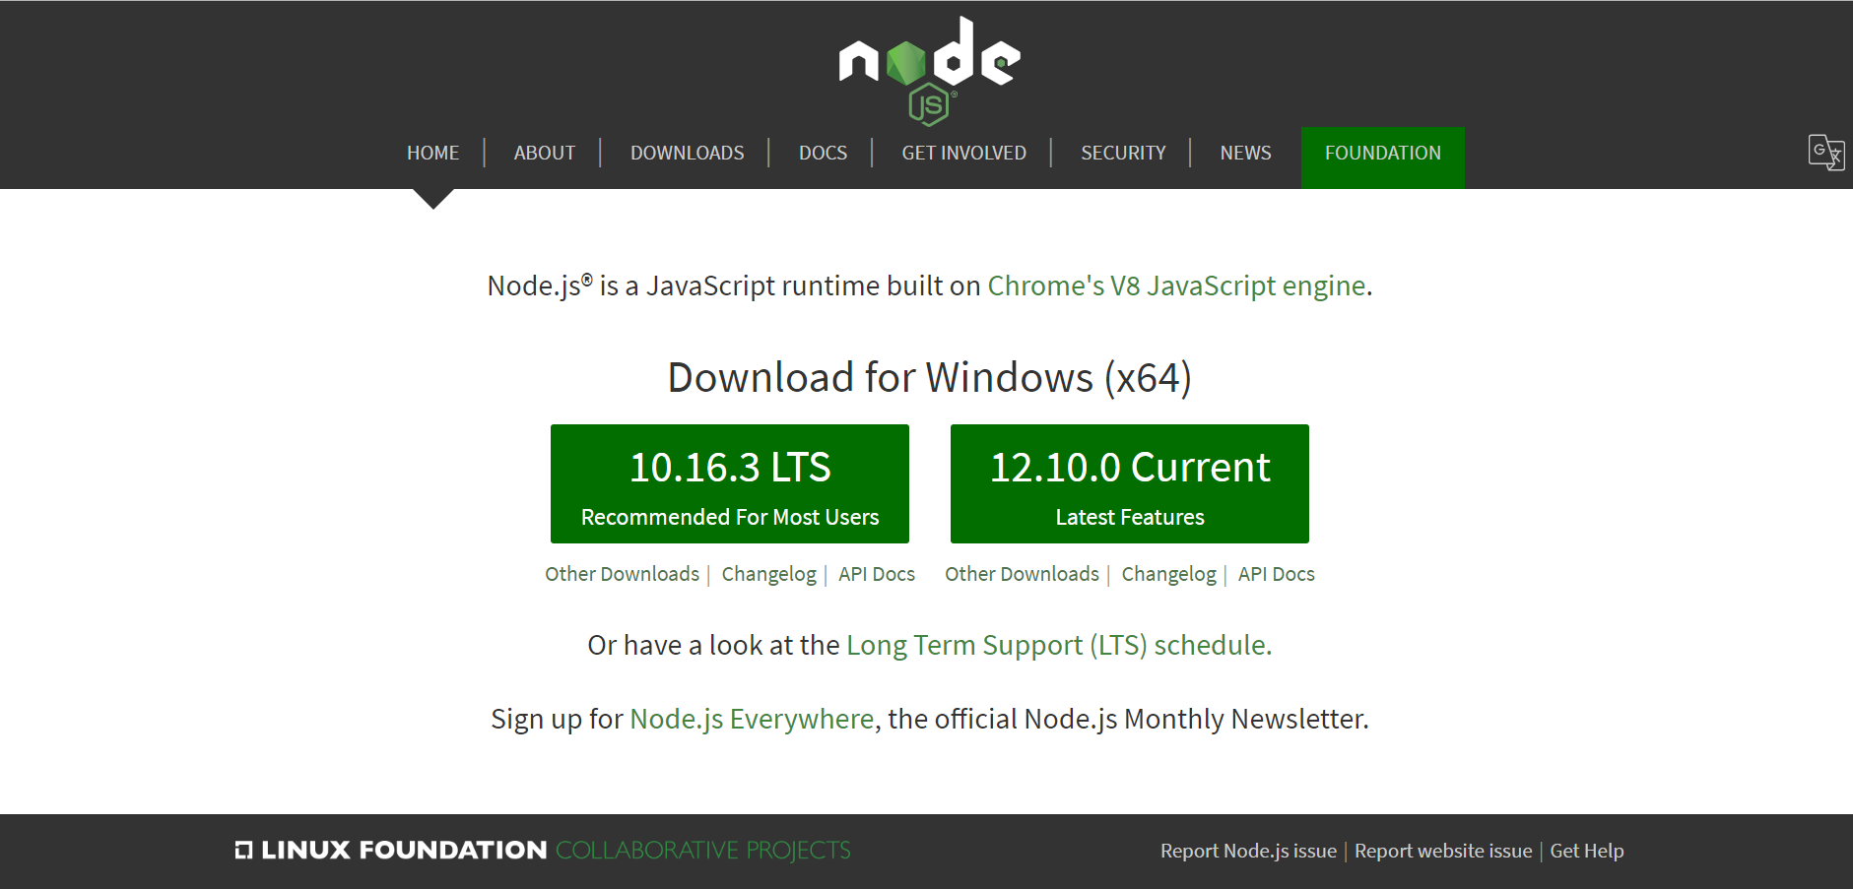

1.2) Click on 10.16.3 LTS

1.3) An installer will be downloaded

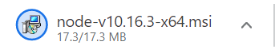

1.4) Double click on the installer, the below window pops up.

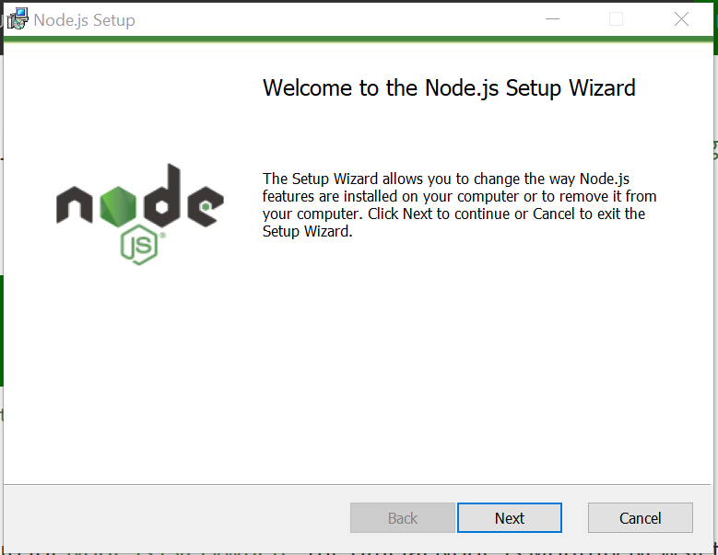

1.5) Click on the next

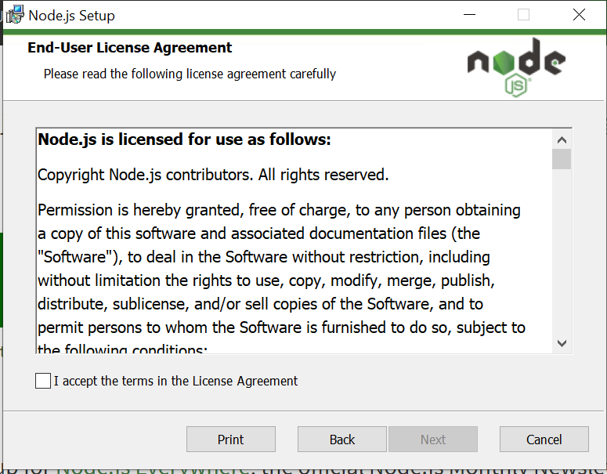

1.6) Click on the “I accept the terms in License Agreement”

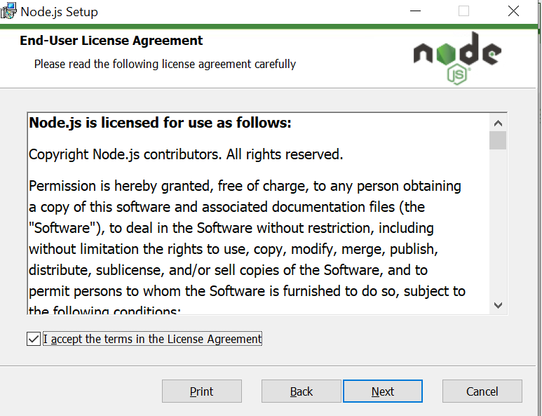

1.7) Click on the next option

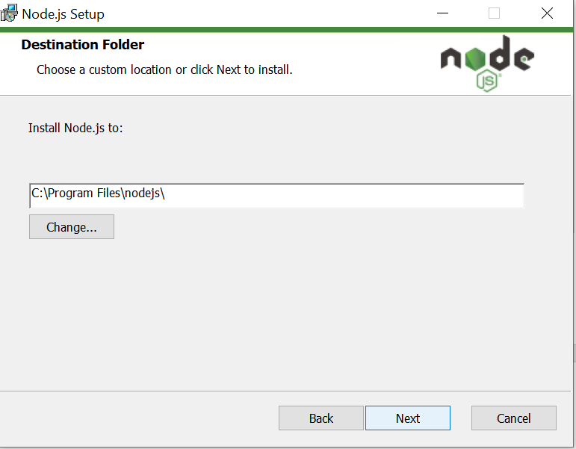

1.8) Click on the next option

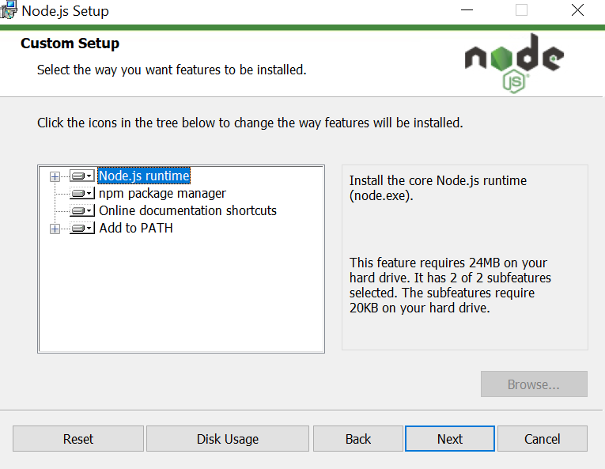

1.9) Click on the next option

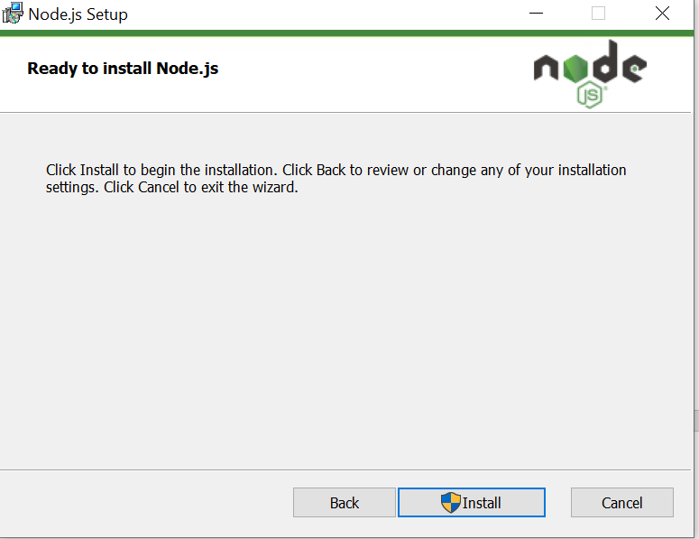

1.10) Click on the install

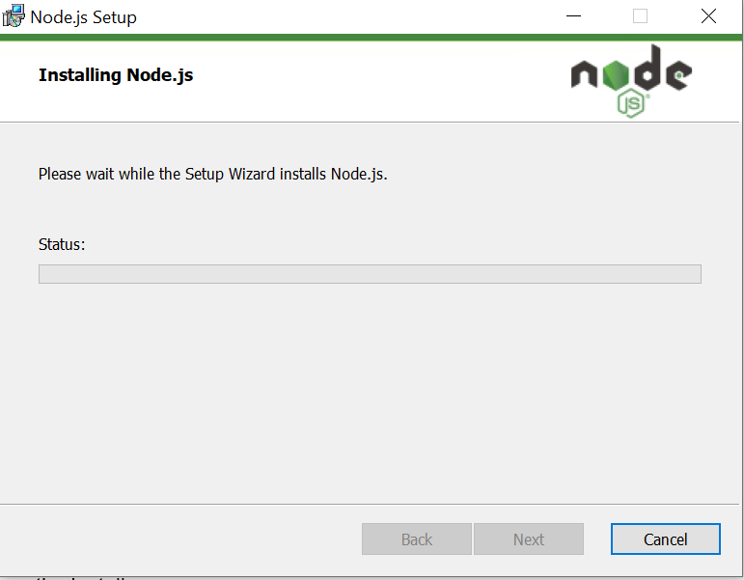

You can see the status of download here

1.11) you will prompted “ Do you want this application to modify your computer ?”

Click on “Yes”

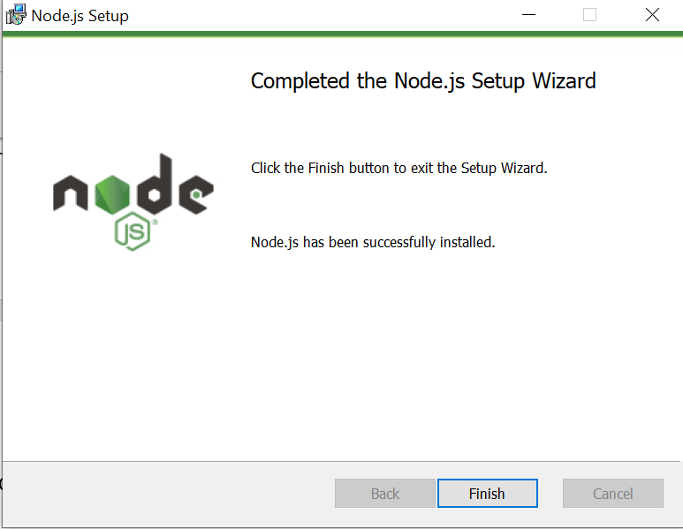

1.12) Click “Finish”

That’s all you have downloaded the node JS

1.13) Check whether node js was installed in your computer.

1.13.1) Create a folder on your Desktop.

1.13.2) Open your command prompt and go to that folder.

1.13.3) And type “node -v” to check the node JS installation. If you see “v..” some number, then you have downloaded successfully.

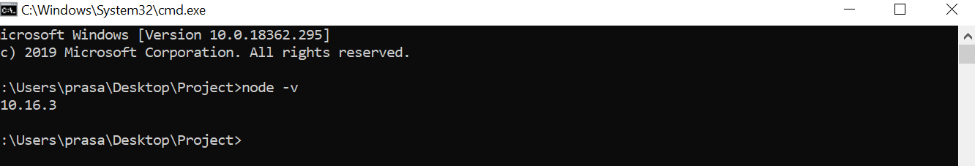

***Step 2: NPM installation:***

What is NPM?

npm is a package manager for the JavaScript programming language. It is the default package manager for the JavaScript runtime environment Node.js. It consists of a command line client, also called npm, and an online database of public and paid-for private packages, called the npm registry.

2.1) Type “npm -v” to check the npm installation. If you see some number then you have downloaded successfully. 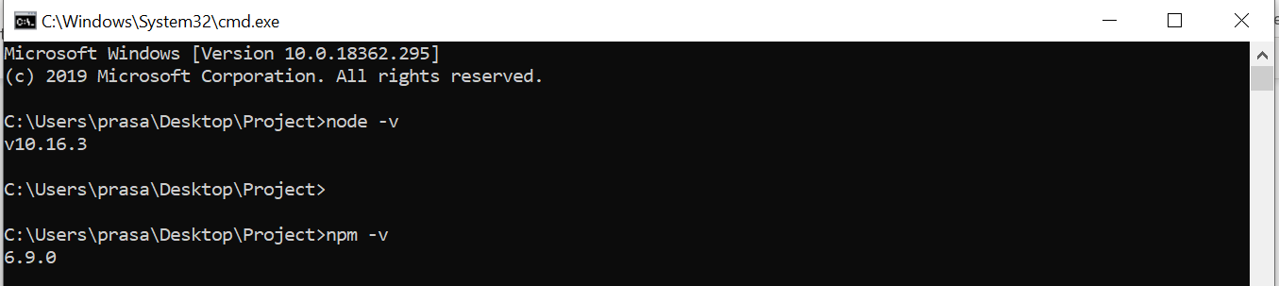

***Step 3: Git Installation:***

What is Git?

Git is a distributed version-control system for tracking changes in source code during software development. It is designed for coordinating work among programmers, but it can be used to track changes in any set of files. Its goals include speed, data integrity, and support for distributed, non-linear workflows.

3.1) Click on “<https://www.atlassian.com/git/tutorials/install-git#windows>”

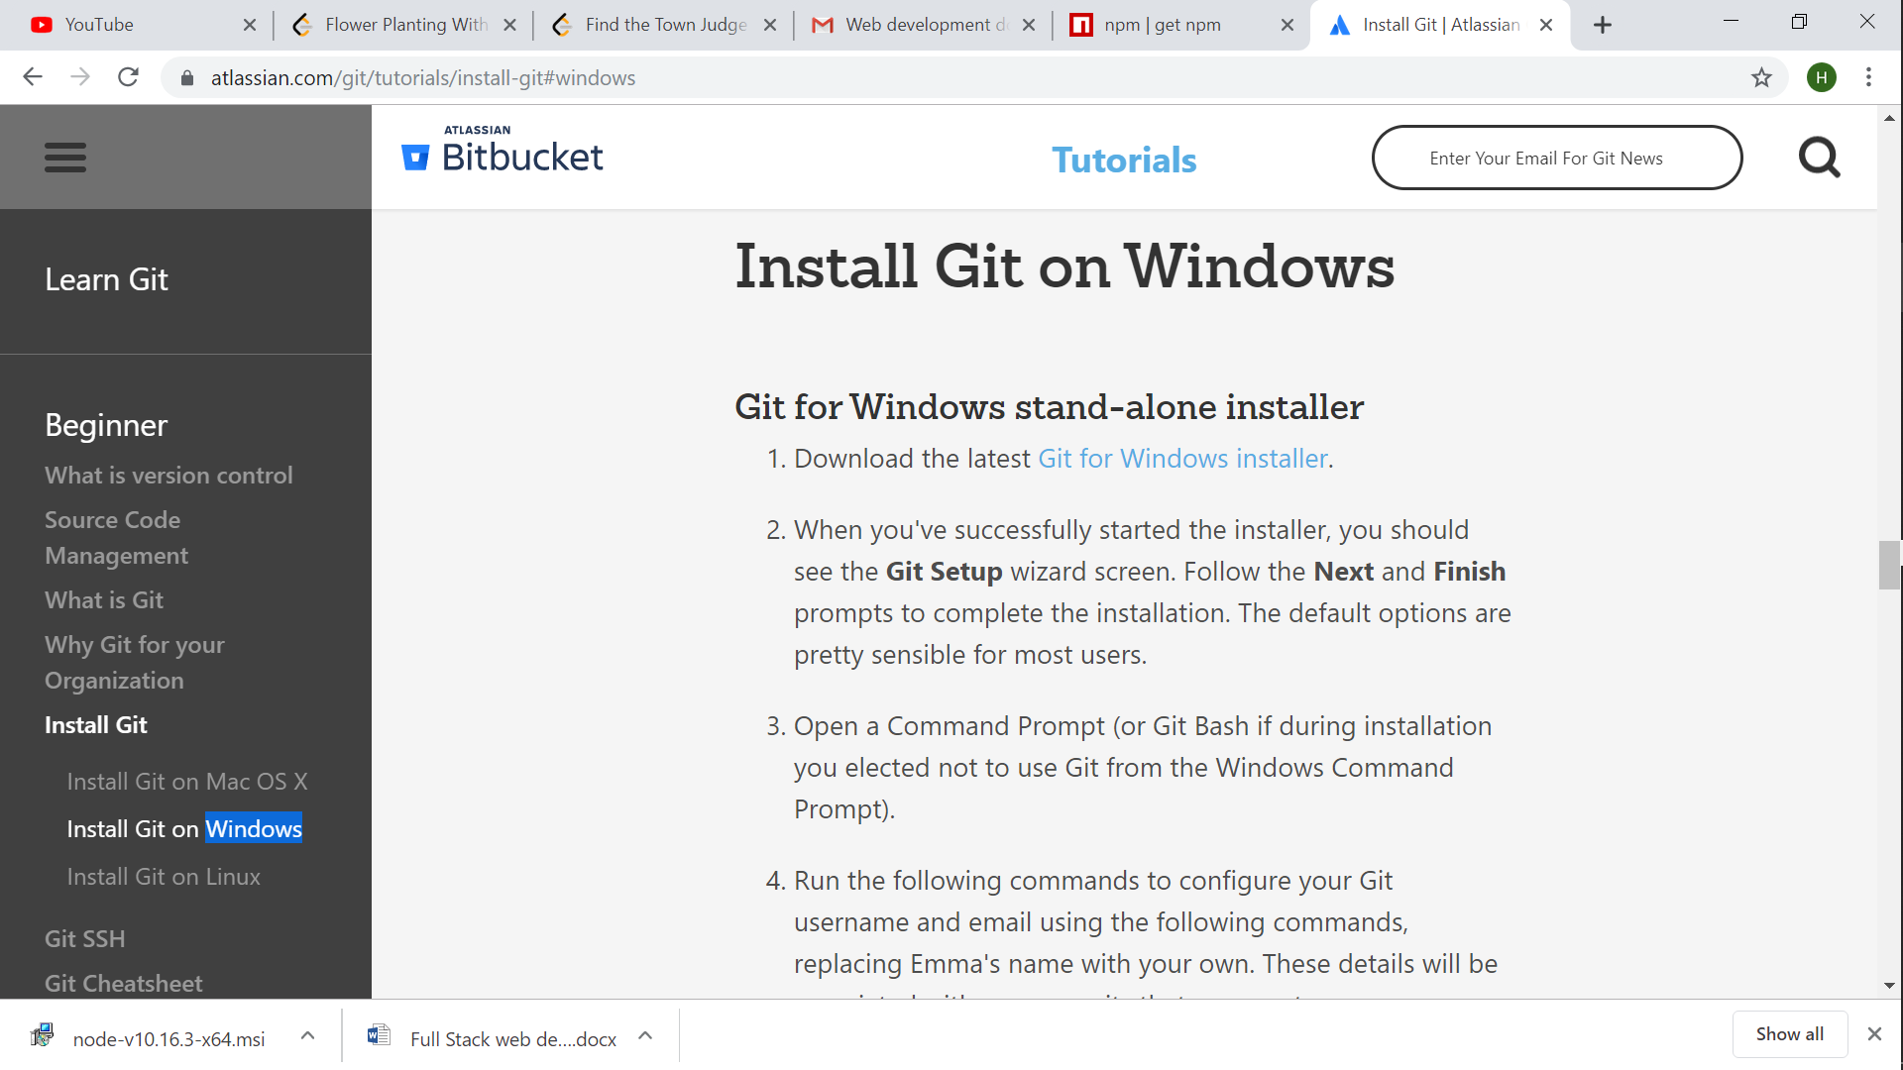

3.2) Click on “Git for Windows installer”

3.3) You will be redirected to the below page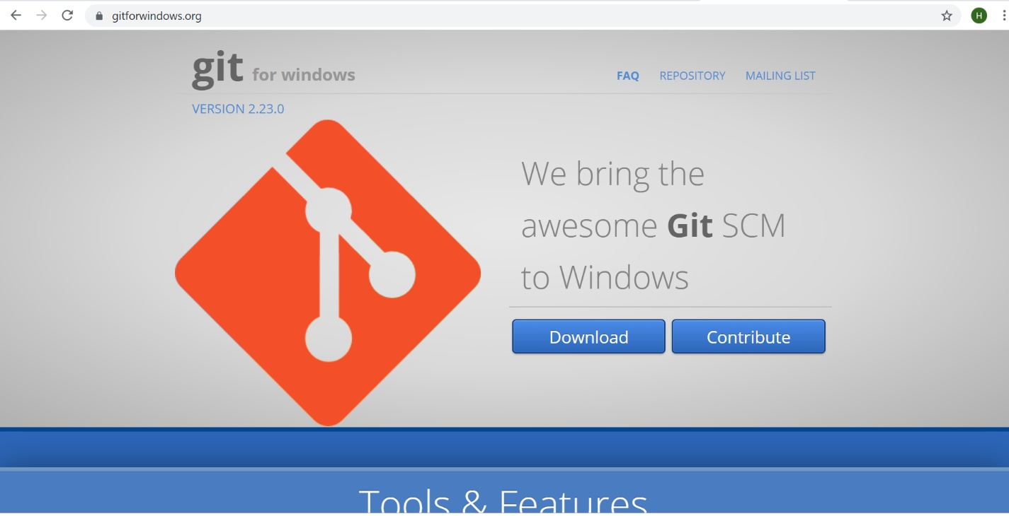

Click on “Download”

3.4) An installer will be downloaded and you can see that at the bottom left corner of your browser.



3.5) Double click on the installer

You will see a prompt “Do you want this app to modify your computer ?”

Click “YES”.

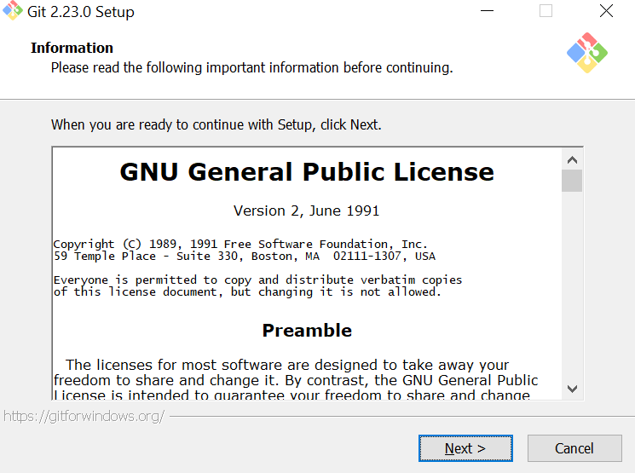

3.6) Click Next, Next, Next, Next until the below screen appears

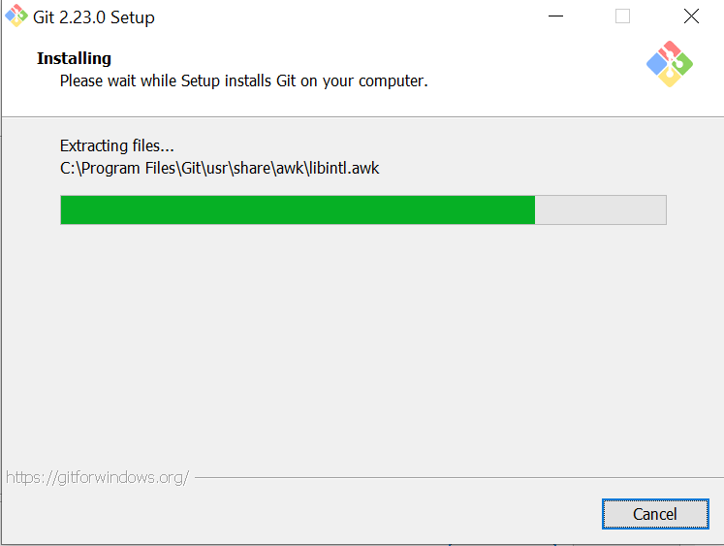

3.7) Click finsh in the below screen.

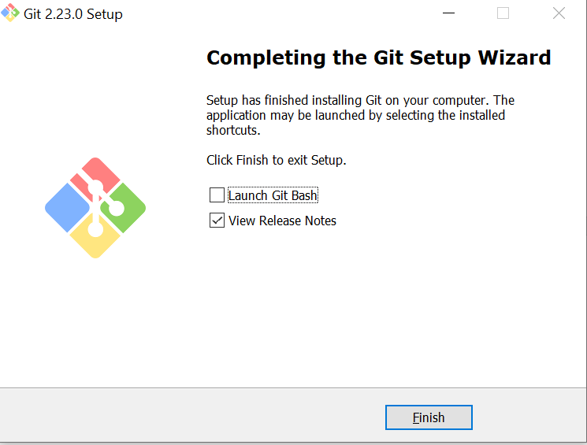

3.8) Check the git installation.

3.8.1) Go to command as shown earlier

3.8.2) Type “ git –version”

3.8.3) If you can see the git version then you have successfully downloaded git

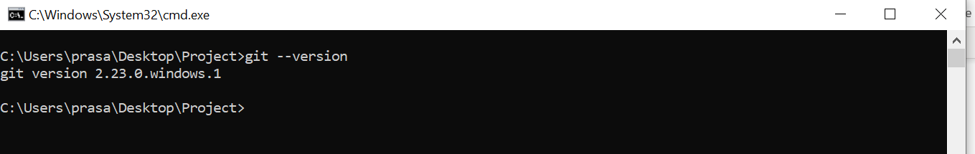

3.8) Type “git clone *enter the link here*”

***FOR MAC Users:***

PREREQUISITES:

Homebrew

Node JS

NPM

Go to google.firebase.com and create an account

HOMEBREW INSTALLATION:

Paste the below command in your terminal and press enter

/usr/bin/ruby -e "$(curl -fsSL https://raw.githubusercontent.com/Homebrew/install/master/install)"

Reference: <https://brew.sh/?source=post_page-----8b8a1842d966---------------------->

NODE JS INSTALLATION:

<https://nodejs.org/en/download/>

CHECK THE VERSION OF NODE AND NPM:

Command 1:

node –v

Command 2:

npm -v

GIT INSTALLATION:

Download latest version of git from: <https://sourceforge.net/projects/git-osx-installer/files/>

Run the following commands:

Type the below command in your terminal:

git --version

git config --global user.name "Emma Paris" // type your username

git config --global user.email "eparis@atlassian.com” // type your git email here

Reference: <https://www.atlassian.com/git/tutorials/install-git>

INSTALL FIREBASE TOOLS USING NPM:

Type the below command in your terminal:

npm install -g firebase-tools

If there is an error in the installation then refer to the below page:

<https://docs.npmjs.com/resolving-eacces-permissions-errors-when-installing-packages-globally>

CHECK THE FIREBASE VERSION:

Type the below command in your terminal:

firebase –V

/* only for localhost */

LOGIN TO YOUR PROJECT CONSOLE:

Type the below commands in your terminal:

firebase login

The pop up page will open in browser

Validate the firebase login and then..

Type the below commands in your terminal:

firebase init // to intialize

firebase list // to see all the projects

firebase serve --only hosting // to host an application

A local server link will be given. Ex: [h**ttp://localhost:5000**](http://localhost:5000)

Copy and paste the above link in your browser, you should see a demo project running.

/*end of local hosting */

Reference: <https://medium.com/@terryjohnpaul20/installation-of-firebase-in-macos-mojave-8b8a1842d966>